
City of Carpinteria
Landscape
Maintenance District
Fact Sheet
Provides a wide array of services to the people & businesses of Carpinteria

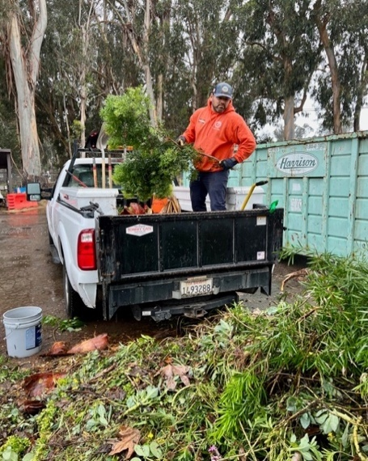
Through the City of Carpinteria’s Landscape Maintenance District (LMD), the City continually provides a wide array of landscaping services that works to reduce wildfire risk through brush, weed, and other fuels management.

Specifically, funding generated by this City assessment helps: 1) prevent trash, litter and debris from accumulating in landscaped areas of Carpinteria, which may enter storm drains and end up in coastal waters and on beaches; 2) maintain landscaping of city medians, parkways, sidewalks and other public spaces; and 3) maintain trees on city streets, medians and other public spaces within the assessment district.

Our Challenges:

With the support of our community, the Landscape Maintenance District (LMD) was established in 1996 (nearly 30 years ago). Since that time, however, assessment rates have not been increased while the costs associated with providing these services have increased by 479.7%, resulting in a growing funding deficit for the services provided by the Landscape Maintenance District.

Over the years, the City has supplemented funds from its General Fund budget to fill the gap in funding for the Landscape Maintenance District. The City projects that in the next several years it may have to reduce the available city budget by over a million dollars annually. This could mean reductions to services, including public safety, street maintenance, parks, and recreational programs in order to continue shifting funds to support the underfunded Landscape Maintenance District.

To ensure continued financial support for the City Landscape Maintenance District, the City of Carpinteria needs additional funding.
- FACT: Assessment rates and revenues have remained flat since 1996 when the local minimum wage was $6.50/hour and gas cost less than $2.00/gallon (on average). Costs have risen significantly since then, and despite the City reducing other services to cover these costs, the City still projects a budget shortfall in the coming years.
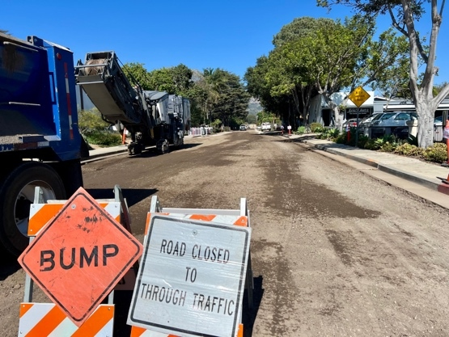
- FACT: Public landscaping services include maintenance and irrigation of trees, plants, shrubs, hedges, and other groundcover. These services also include removing landscaping debris from City drainage systems, maintenance of sidewalks and bikeways, and weed and graffiti abatement.
- FACT: The City currently supports landscaping services for approximately 184 acres of public land, not including parks. The Casitas Pass Road and the Via Real Triangle, the Costal Vista Trail, and the Santa Monica Creek Trail are some of the larger areas where the City manages landscaping services.
- FACT: As our climate continues to change, and summers continue to get hotter, tree coverage is a vital tool that the City has to combat some of the worst effects of heat. Studies have shown that increased tree coverage across communities reduces the effects of heat waves by cooling the surrounding areas.
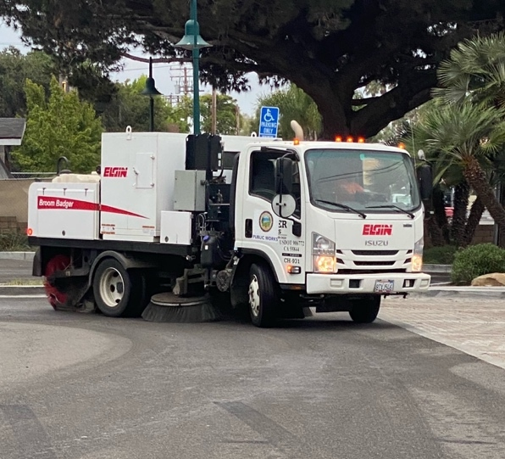
- FACT: Safe, clean and well-maintained public landscaping along streets, trails, and public parking areas help maintain the quality of life and make our community a desirable place to live.
- FACT: City landscaping services help provide a benefit to Carpinteria residents, businesses and visitors through an improved pedestrian experience, increased fire abatement, support of community sustainability and environmental goals, and safer, better vehicle outcomes for drivers and bicyclists.
- FACT: The City has sought to maintain landscaping services at current levels without increasing property taxes. Despite efforts to cut costs and maintain tight cost controls, without additional funding to cover the increasing city landscape maintenance costs, the City of Carpinteria will need to revise its landscape maintenance budget for these services.
Identified Solution:

To continue the maintenance, operation and servicing of landscaped areas that directly benefit assessed parcels within the City of Carpinteria, the City is proposing the formation of an updated Landscape Maintenance District in compliance with Proposition 218.

What the updated Landscape Maintenance District proposes to fund:

- Continued maintenance to help reduce wildfire risk through brush, weed and other fuels management and abatement in landscaped public areas within the district.

- Continued maintenance to help prevent trash, litter and debris from accumulating in landscaped areas which may enter storm drains and end up in coastal waters and on beaches.

- Continued landscaping maintenance/servicing of street trees, landscaped medians, parkways, sidewalks and other public spaces that provide a direct and proportional benefit to properties within the district.

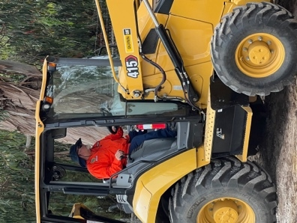
Proposition 218 Ballot Proceeding:

California’s Proposition 218 (the “Taxpayers Right to Vote on Taxes Act”), which was approved by voters across the state in 1996 as an amendment to the California Constitution, requires a “mail ballot proceeding” among local property owners (not registered voters) for any proposed new or increased assessment. Formation of an updated Landscape Maintenance District will be conducted according to the requirements established by Proposition 218, including providing all property owners located within the district the opportunity to vote on the proposed assessment. For example, a ballot and notice will be mailed to all property owners who would be asked to pay the proposed Landscape Maintenance District No. 2025-1 assessment. If the proposed assessment is approved, it would replace the existing assessment that was established in 1996. The replacement District would establish updated assessments that more accurately reflect current costs and ensure long-term program sustainability. If the proposed ballot proceeding to replace the existing Landscape Maintenance District passed, it would be adjusted to $165.76/per year (or $13.81/per month) for City of Carpinteria single family residential property owners within the District, with an annual adjustment provision equal to the greater of 3% or the percentage change in the Consumer Price Index for All Urban Consumers, not to exceed 6%.

The assessment also includes accountability requirements so that funds are used as promised, with public disclosure of all spending and annual independent audits which will be available online. No funds from this assessment would go to the City’s General Fund.

For more information, visit our website at: carpinteriaca.gov/assessmentdistricts OR contact: Ryan Kintz,
Assistant City Manager, at: assessmentdistricts@carpinteriaca.gov.

