
Helps to protect public & private property from high tides & winter storms.
Fact Sheet
City of Carpinteria
Winter Berm District

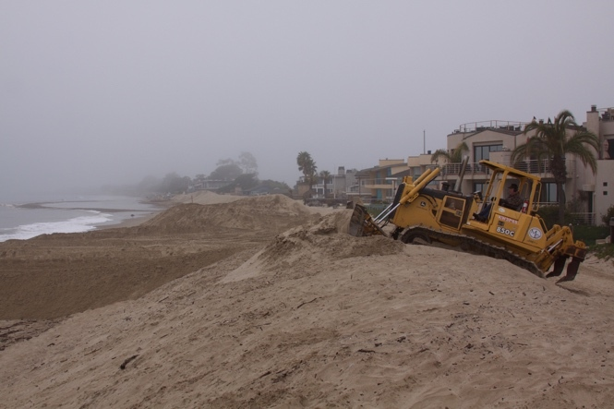
Every year through the City of Carpinteria Winter Protection Berm Assessment District No. 5, the City constructs a berm to help protect public and private property from high tides and winter storms. The berm helps preserve the integrity of the homes and businesses that are near the shore. The berm is typically built in October and dismantled the following March every year.

Our Challenge:

With the support of our community, Winter Berm District No. 5. was established in 1992 (33 years ago). Since that time, however, assessment rates have not been increased, while construction, maintenance, management, contingency and emergency response costs have increased by 275% (from $25,300 in 1992 to $94,771 in 2025).

As a result, the City has supplemented funds from its General Fund budget to fill the gap in funding for the Winter Berm. The City projects that in the next several years it may have to reduce the available city budget by over a million dollars annually. This could mean reductions to services, including public safety, street maintenance, parks, and recreational programs in order to continue shifting funds to support the underfunded Winter Berm District.

In order to ensure continued financial support for the berm’s yearly construction, to expand the existing Winter Berm District to include all at risk properties, and avoid reductions to other services, the City of Carpinteria needs additional funding.
- FACT: Prior to 1992, frequent winter storm surges (or floods) caused significant property damage to parcels along the ocean front of the city. The damage spurred the City of Carpinteria and property owners to invest in the berm in order to provide protection from high tides and storm surges during the winter months.
- FACT: Since 1997 the Berm has protected homes and businesses near the ocean front from countless storms, saving property owners costs for repairs and renovations.
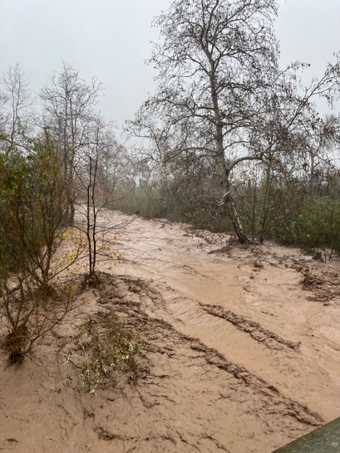
- FACT: In 2023, a strong storm caused a minor breach in the berm. Additional investment in our winter berm to prevent future breaches like the one we saw in 2023 is needed.
- FACT: Winter storms are becoming more severe and unpredictable. With a greater variance of winter storms, additional funding is needed to better protect the property nearest the Carpinteria City Beach.
- FACT: The berm helps protect property values and provides potential reductions in flood insurance premiums.
- FACT: A new flood risk analysis shows that a larger number of properties at or near the shoreline are at risk of flooding than were previously determined in 1992 when the Berm District boundaries were drawn. Currently, the Winter Berm District only contains 80 parcels as part of the special district. Meanwhile, the new flood risk analysis indicates that 394 parcels are at risk of significant flooding during winter storms and high tides.

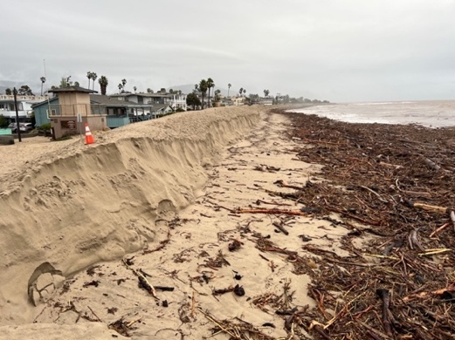
Identified Solution:

The berm program consists of seasonal construction and removal of an earthen berm approximately 1,375 feet in length along the Carpinteria City Beach. Once constructed, the berm must be monitored, maintained, and repaired during the winter storm season to ensure that it provides reliable protection.

Emergency response activities are often required during significant weather events to reinforce the structure and prevent overtopping or erosion. In addition to physical construction and maintenance, the program requires administrative oversight, compliance with legal noticing and reporting obligations, and the management of contractual and budgetary responsibilities. A contingency allocation is also necessary to address unforeseen events such as unusually severe storms.

To appropriately fund the continued yearly construction, maintenance, management, contingency and emergency response of the berm, the City of Carpinteria is considering the formation of a replacement assessment district, the Carpinteria Coastal Berm Assessment District, which would require a Proposition 218 ballot proceeding. The replacement District would establish updated assessments that more accurately reflect current costs and ensure long-term program sustainability. Formation of the Coastal Berm Assessment District would replace the levy of assessments within the existing District beginning in Fiscal Year 2026/27. All costs associated with berm construction, maintenance, and emergency response would be consolidated into a single, updated assessment.
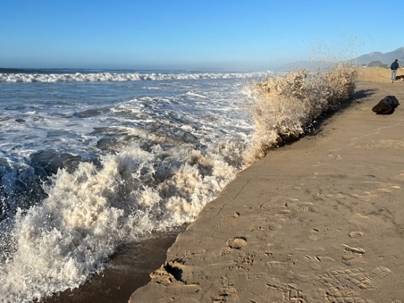
California Proposition 218 (the “Taxpayers Right to Vote on Taxes Act”), which was approved by voters across the state in 1996 as an amendment to the California Constitution, requires a mail ballot proceeding among local property owners (not registered voters) for any proposed new or increased assessment. Formation of an updated Winter Protection Berm Assessment District will be conducted according to the requirements established by Proposition 218, including providing all property owners located within the district the opportunity to vote on the proposed assessment. For example, ballot and notice will be mailed to all property owners who would be asked to pay the proposed assessment for the Coastal Berm Assessment District No. 5. If the proposed assessment is approved, it would replace the existing assessment that was established in 1992. The replacement District would establish updated assessments that more accurately reflect current costs and ensure long-term program sustainability. If the proposed ballot proceeding to replace the existing Winter Protection Berm Assessment District passed, the proposed maximum assessment (Rate per Equivalent Benefit Unit) would be $235.42/ per year (or $19.62/ per month), with an annual adjustment provision equal to the greater of 3% or the percentage change in the Consumer Price Index for All Urban Consumers, not to exceed 6%.

Without the improvements, the adjacent neighborhoods and properties (subject parcels) face a substantially higher risk of flooding, structural damage, erosion, and associated financial losses. By contrast, the presence of the berm directly mitigates that exposure, resulting in tangible, parcel-specific advantages, including:

- Reduced risk of property damage and associated repair or replacement costs due to storm-driven wave action and coastal flooding;
- Lower likelihood of personal financial losses, business interruption, or displacement resulting from flood events;
- Potential reductions in flood insurance premiums, where applicable, due to demonstrated flood protection measures in place; and
- Preservation or enhancement of long-term property value as a result of improved site stability and reduced hazard designation.

By law, funds from this assessment can only be used to provide services within the Coastal Berm Assessment District boundaries. No funds from this assessment would go to the City’s General Fund. The budget for maintenance and services funded by this assessment would be provided to the public annually.

For more information, visit our website at: carpinteriaca.gov/assessmentdistricts OR contact: Ryan Kintz,
Assistant City Manager, at: assessmentdistricts@carpinteriaca.gov.

