EXAMPLE
Stormwater Treatment Facilities
Operation and Maintenance Plan
for a Commercial Project
123 Main Street
Anytown, USA

January 2017

XYZ Corporation
Jane Jones, 805-555-1212

This example prepared by Dan Cloak Environmental Consulting
for County of Santa Barbara Project Clean Water
to assist users of the Stormwater Technical Guide
Table of Contents

I. Introduction 3
I.A. Site Description 3
II. Designation of Responsible Individuals (to be completed in Final O&M Plan) 3
II.A. Designated Contact for Operation and Maintenance 3
II.B. Off-Hours or Emergency Contact 3
II.C. Corporate Officer (authorized to execute agreements with the City, Town, or County) 3
II.D. Initial Training of Responsible Individuals 3
III. Facilities to be Maintained 3
III.A. Facility Descriptions 3
III.A.1. Bioretention Facility #1 4
III.A.2. Bioretention Facility #2 4
III.A.3. Bioretention Facility #3 4
IV. Maintenance Activities 5
IV.A. General Maintenance Rules 5
IV.B. Maintenance Schedule 5
IV.B.1. Routine Activities 5
IV.B.2. Following Significant Rain Events 5
IV.B.3. Prior to the Start of the Rainy Season 6
IV.B.4. Annually During Winter 6

Figures
Figure 1. Bioretention Cross Section (Schematic) 4

Attachments
Stormwater Control Plan Exhibit
As-Built Drawings (in Final O&M Plan)

Introduction

Site Description
The site is flat and abuts Main Street, a major arterial. Total site area is 28,800 square feet, including:
- A 4,680 SF single-story retail building.
- About 15,000 SF paved area including walkways, a plaza, parking areas, and circulation. Circulation includes a drive-through lane for a coffee shop.
Soils are silty clays (Hydrologic Soil Group “D”).
Stormwater treatment is provided by three bioretention facilities designed to capture and retain runoff from the first 1.5 inches of rain. During larger storms and high-intensity events, the bioretention facility surface reservoir overflows. Treated runoff and untreated overflow is discharged via drop inlet into the public storm drain system on Main Street.

Designation of Responsible Individuals (to be completed in Final O&M Plan)

Designated Contact for Operation and Maintenance
[name, title or position]
[address]
[telephone and email]

Off-Hours or Emergency Contact
[name, title or position]
[address]
[telephone and email]

Corporate Officer (authorized to execute agreements with the City, Town, or County)
[name, title or position]
[address]
[telephone and email]

Initial Training of Responsible Individuals
Following completion of construction, the bioretention facilities will be maintained by the contractor for two years, except for routine policing for trash, which will be done by the owner’s and lessee’s personnel. During this 2-year period, the owner’s landscape maintenance crew will coordinate to meet with the contractor’s personnel on-site during maintenance. At these times, the contractor’s personnel will demonstrate proper maintenance procedures.

Facilities to be Maintained

Facility Descriptions
There are three bioretention facilities on-site. All have the following features:
- Surrounded by a concrete curb. Where adjacent to pavement, curbs are thickened and an impermeable vertical cutoff wall protects the pavement subgrade from moisture intrusion.
- Each layer built flat and level. See Figure 1.
- Class 2 permeable, Caltrans specification 68-2.02F(3). Depths are as shown in the as-built drawings.
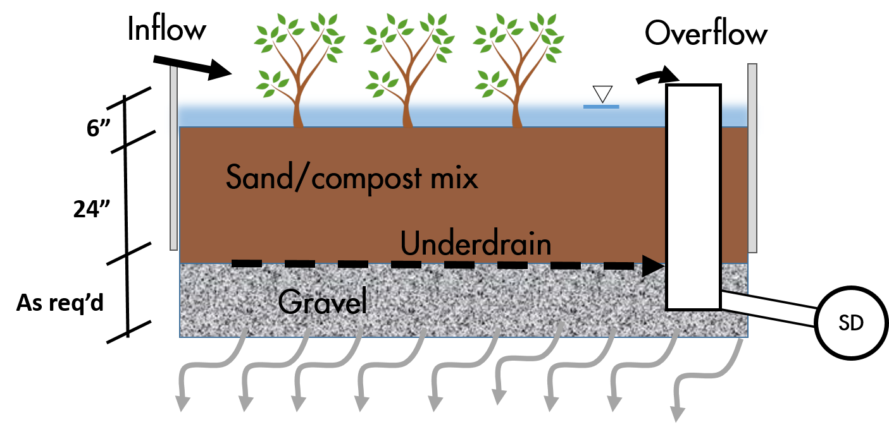
Figure 1. Bioretention Cross-Section (schematic)
- 18 inches mixture of washed sand (60-70%) and compost (30-40%)
- 4 in. dia. PVC SDR 35 perforated pipe underdrain, installed with the invert at the top of the Class 2 permeable layer with holes facing down, and connected to the overflow structure at that same elevation
- 6-inch-deep reservoir between top of soil elevation and overflow grate elevation
- Concrete drop inlet with frame overflow structure, with grate set to specified elevation, connected to storm drain in Main Street
- Plantings including Carex globosa, Eleocharis macrostachya, Muhlenbergia rigens
- Irrigation system with drip emitters and “smart” irrigation controllers
- Sign identifying the facility as a stormwater treatment facility.

Bioretention Facility #1
See the attached Stormwater Control Plan Exhibit. Bioretention Facility #1 receives drainage from Drainage Management Area (DMA) 1, which includes the roof of the refuse area and the delineated portion of the parking lot, totaling 2,805 SF of impervious surface. Inflow is via curb cuts that accept sheet flow from the pavement. The facility underdrain is connected to the overflow structure [specify in final O&M Plan], which is connected via a [specify pipe] to the City’s storm drain system at a drop inlet in front of the site.

Bioretention Facility #2
See the attached Stormwater Control Plan Exhibit. Bioretention Facility #2 receives drainage from DMA-2, comprising the walkway on the north side of the building and the delineated portion of the parking lot, totaling 6,130 SF of impervious surface. Inflow is via curb cuts that accept sheet flow from the pavement. The facility underdrain is connected to the overflow structure [specify in final O&M Plan], which is connected via a [specify pipe] to the City’s storm drain system at a drop inlet in front of the site.

Bioretention Facility #3
See the attached Stormwater Control Plan Exhibit. Bioretention Facility #3 receives drainage from DMA-3, comprising the roof of the building, the walkway on the south side of the building, and the plaza on the street side. The roof drainage is piped via a tight-lined downspout on the south side of the building that goes under the drive-through aisle and “bubbles up” within the bioretention facility. DMA-8 also includes the driveway and drive-through lane to the south and west of the building, and the parking area on the west side of the site, north side of the building and the delineated portion of the parking lot, totaling 6,369 SF of impervious surface. Inflow from the paved areas is via curb cuts that accept sheet flow from the pavement. These are labeled on the Stormwater Control Plan Exhibit. The facility underdrain is connected to the overflow structure [specify in final O&M Plan], which is connected via a [specify pipe] to the City’s storm drain system at a drop inlet in front of the site.

Maintenance Activities

General Maintenance Rules
At no time will synthetic pesticides or fertilizers be applied, nor will any soil amendments, other than aged compost mulch or sand/compost mix, be introduced. The top of soil surface will be maintained at or near the design elevation throughout. Irrigation systems will be maintained to conserve water while maintaining plant health.
Although it is unlikely to be needed, if plants are not thriving compost tea may be applied at a recommended rate of 5 gallons mixed with 15 gallons of water per acre, up to once per year between March and June. Compost tea will not be applied when temperatures are below 50°F or above 90°F or when rain is forecast within the next 48 hours.
The following may be applied for pest control if needed:
- Beneficial nematodes
- Safer® products
- Neem oil
Plants may need to be replaced with the following mix as specified by the landscape architect [list species] or with similar plantings appropriate for the unique conditions.

Maintenance Schedule
The three bioretention facilities will be maintained on the following schedule at a minimum.

Routine Activities
The facilities should be examined daily for visible trash, and trash will be removed. Any graffiti, vandalism, or other damage will be noted and addressed within 48 hours.
The planted areas will be weeded by hand approximately monthly. At this time plants will be inspected for health and the irrigation system will be turned on manually and checked for any leaks or broken lines, misdirected spray patterns etc. Any dead plants will be replaced.

Following Significant Rain Events
A significant rain event will be considered to be one that produces approximately a half-inch or more rainfall in a 24-hour period. Within 24 hours after each such event, the following will be conducted:
The surface of the facility will be observed to confirm there is no ponding.
- Inlets will be inspected, and any accumulations of trash or debris will be removed. Any erosion at inlets should be restored to grade.
- The surface of the mulch layer will be inspected for movement of material. Mulch will be replaced and raked smooth if needed.
- Outlet structure will be inspected for any obstructions to assure that mulch is not washed out.

Prior to the Start of the Rainy Season
In September or each year, facility inlets and outlets will be inspected to confirm there is no accumulation of debris that would block flow. Stormwater should drain freely into the bioretention facilities. If not previously addressed during monthly maintenance, any growth and spread of plantings that blocks inlets or the movement of runoff across the surface of the facility will be cut back or removed.
If the facilities are not completely drained in 24 hours, the underdrain may be clogged. Check the overflow outlet to determine if the underdrain is performing properly. There should be no filter fabri or geotextile in the horizontal layers or wrapped at the underdrain. If the underdrain is working, the bioretention media may contain fines. Replace material with mixture of 30-40% aged compost and 60-70% washed granular sand, no fines.

Annually During Winter
Once, in December – February of each year, vegetation will be cut back as needed, debris removed, and plants and mulch replaced as needed. The concrete work will be inspected for damage. The elevation of the top of soil and mulch layer will be confirmed to be consistent with the 6-inch reservoir depth.
Stormwater Control Plan Exhibit

Example Commercial Site
123 Main Street
Anytown, USA
No Scale

