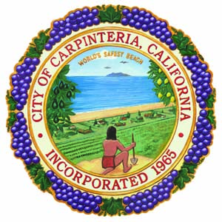
Volunteer Contact
Olivia Uribe Mutal,Program Manager
Emergency Services, Volunteers & Outreach
805-755-4401
OliviaU@carpinteriaca.gov

Volunteer Opportunities

Within the City
- Library: (805) 684-4314 - 5141 Carpinteria Ave, Carpinteria, CA 93013
- Community Emergency Response Team (CERT): Volunteer Contact - Olivia Uribe Mutal
- LISTOS: Volunteer Contact - Olivia Uribe Mutal
- HOST Program: Volunteer Contact- Olivia Uribe Mutal
- Marsh Docent: Andrea Adams-Morden (805) 886-4382 carp_parks@yahoo.com
- Pool: Amber Workman, Aquatics Superintendent (805) 566-2417 AmberW@carpinteriaca.gov
- Environmental Programs: Erin Maker, Environmental Program Manager 805-880-3415 erinm@carpinteriaca.gov

Outside of the City
- Seal Watch https://carpinteriasealwatch.org (805) 684-2247
- Carpinteria Beautiful – President is Bryan Mootz b998cc@gmail.com
- Santa Monica Creek Clean Up - Trail Steward Ray Kolbe rwkolbe@gmail.com (805) 705-3429
- Seniors Inc/Seniors Programming with City - carpsandy@gmail.com

