Junior Lifeguard Program 2021

City of Carpinteria

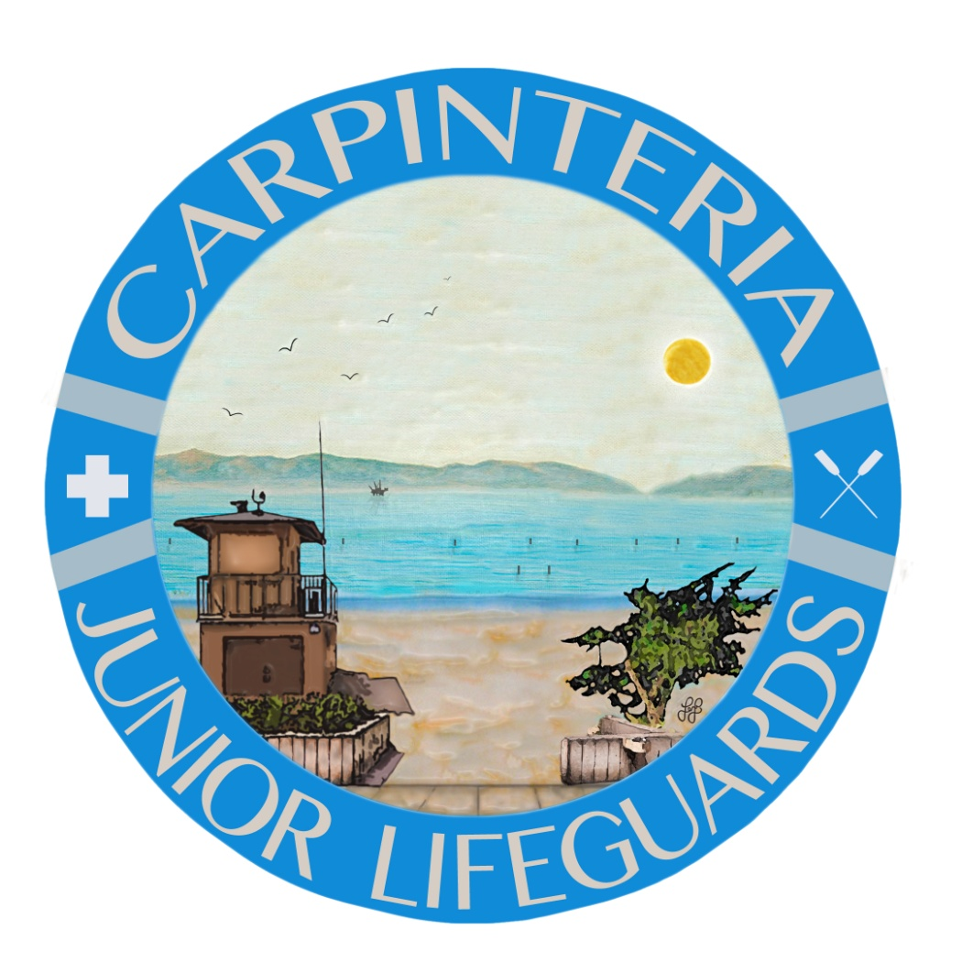
Parks and Recreation

Parent and Participant Packet

Program Overview

Age Requirements

Program Dates and Location

Weekly Handout

Contact Us

Arrival & Departure

Attendance

Swim Test

Instruction and Supervision

Mandatory Aquatic Participation

Daily Requirements

Field Trips Information

Competition Information

Uniforms

Lectures

Discipline Actions

Donations

JG Contract – Please return before participation

Calendar

Medical/Liability Release

Registration Form
Dear Parents and Participants,

The Carpinteria Junior Lifeguard Program welcomes you and your child to another summer full of personal growth and fun! We have been working very hard this year to ensure the Carpinteria Junior Lifeguards of 2021 will have a positive beach experience while adhering to social distancing, and other requirements mandated by the County Public Health Department and the CDC. It is our goal to provide experience that emphasizes ocean safety, marine environment education and personal growth.

PROGRAM OVERVIEW

The mission of the Carpinteria Junior Lifeguard program is to introduce young people to safe marine and aquatic recreation opportunities. Further, it is our goal to improve young people’s physical conditioning, their understanding and respect for the environment, and their respect for themselves as well as others, all while having a great time at the beach!
We accomplish our goals through daily activities including stretching, beach runs, open water swimming, paddle boarding, body surfing, beach games and competitions. Daily physical contact with our environment allows junior lifeguards to learn how to respect and appreciate the world around them. Lectures and discussions are held weekly to educate participants on various topics such as water safety, CPR overview, beach hazards, waves and tides. Participants gain respect for themselves as well as others by contact with instructors and growing relationships with other youths in a team building environment. In addition, participants are asked to practice many of the skills and techniques utilized in professional lifesaving organizations.

The cost of the 2021 Carpinteria Junior Lifeguard Program is $450.

AGE REQUIREMENTS

Junior Lifeguards range in ages from nine to seventeen years old. We are willing to accommodate younger participants, who are not yet quite the age of nine, if the prospective participant and their parents feel confident that they can keep up with all daily activities. Participants must work out and participate in all activities with their appropriate age group. The age groups are as follows:

A’s 14 – 17 years old

B’s 12 – 13 years old

C’s 9 – 11 years old

PROGRAM DATES AND LOCATIONS

Our program is seven weeks long, beginning the week of June 21st, and ending on August 6th.
Each day participants are expected to arrive at their designated drop off location promptly at 9:30 a.m. We strongly encourage all participants to arrive at least ten minutes early but no sooner to get their belongings organized, look at the daily activity board, and be ready to stretch. Our program ends each day at 12:30 p.m. Please pick your child up promptly, if not able to pick them up, give direct instruction otherwise.

Program Schedule
Monday-Friday 9:30am-12:30pm

Drop off/Pick up locations
C Group – Ash Avenue
B Group – Holly Avenue
A Group – Elm Avenue

*IMPORTANT* All JG’s must have helmets when riding BIKES, SKATEBOARDS, AND SCOOTERS!!! Or they will walk!!!!
*Junior Lifeguards are not allowed to drive cars from the pool back to the beach*

WEEKLY NEWSLETTER

Each Monday we will email a weekly newsletter. This will provide a general summary of that week’s activities and important upcoming events or information parents need to be aware of. Please make sure that you get on the email list. The weekly newsletter dates and times will always be current, if they differ from the calendar, please refer to the weekly newsletter. Weekly newsletter will also be put on-line at our website: https://carpinteriaca.gov/parks-and-recreation/junior-lifeguards/

CONTACT US

E-mail is the easiest and fastest way to reach us: leilanies@ci.carpinteria.ca.us

- Junior Lifeguard Coordinator (805) 881-2806
- Boathouse (805) 684-7613
- Carpinteria Community Pool (805) 566-2417

City of Carpinteria:
- Ann Meyer, Management Assistant (805) 755-4432
- Matt Roberts, Parks and Recreation Director (805) 755-4449

PARTICIPANT ARRIVAL AND DEPARTURE

Parents: It is the sole responsibility of each parent or guardian to ensure safe travel for their child to and from the Junior Lifeguard Program each day. Please discuss a designated plan in advance each day with your child so they understand when and where to meet you. Please ensure that you specify how your child will be arriving and departing on the “Junior Lifeguard Contract Page”, so that instructors are aware of your plans. This is to ensure that we are aware of how your child will be arriving and departing each day. The City of Carpinteria and the Junior Lifeguard Program are not responsible for participants outside of the scheduled program hours and activities. Parents are responsible for their children immediately prior to and immediately following scheduled program hours.

Participants: Please remember that while wearing the Junior Lifeguard uniform within the community you are very easily recognizable and that your actions are representing our team as a whole. Participants should act in a responsible and courteous manner and represent our program and city in a positive manner. Please arrive and remain in uniform each day.

Arrival
During arrival, participants will be required to wear face coverings. Each group will have a designated drop-off location. Each group will have an EZ up at their drop off location. Each participant will report to their instructor in their area. This will help stagger the groups to ensure social distancing. Parents are not allowed to walk them up to the drop off area. Wear a face covering and stay in your car or behind the cones near the restrooms.

Departure
Pick up will be at 12:30 pm. The designated pick-up location is the same as their drop off location. Instructors and participants will wear face coverings. Parents must wear face coverings when picking up. If leaving on bike, participants will be dismissed along with their group.

ATTENDANCE

Attendance is taken daily for each group. Regular attendance is encouraged and will allow participants to fully benefit from the program. Placements on teams for competitions are often made during the three weeks prior to each meet. It is important for participants to be present each day in order to try-out and be placed on specific teams. We understand that on occasion parents and participants may have other responsibilities and we are willing to accommodate. Please notify us if your child will be absent, by e-mailing leilanies@ci.carpinteria.ca.us or texting Leilanie at (805) 881-2806, by 8:30a.m. at the very latest of the day of absence.

SWIM TEST

*ALL NEW JGs MUST ATTEND THE SWIM TEST PRIOR TO THE START OF JGs. DATES ARE LOCATED ON CALENDAR*

The Junior Lifeguard Program is NOT a “learn to swim” course. Therefore, participants are given a tryout test to determine if they have the minimum skills needed to benefit from the program. We strongly encourage parents to work with their child on swimming skills before the beginning of the program to ensure that their child can pass the test with confidence. Lessons are available at the Carpinteria Community Pool! There will be several swim challenges during the summer. One of the challenges being the first week of junior lifeguards at Ash Ave. It will consist of each participant swimming to the first red buoy, about a 100- yard swim, with no time limit.

MANDATORY AQUATIC PARTICIPATION

All program participants must be able to swim, enter the ocean readily and participate in water activities on a daily basis. Parents should be aware that rigorous physical exercise and ocean swims are a daily part of the program.

INSTRUCTION AND SUPERVISION

Junior Guards are instructed by trained and qualified ocean lifeguards. All of the instructors have successfully completed an intensive open water lifeguard training course. Instructors are also certified in emergency first aid and CPR for the professional rescuer. Many of the instructors have been Junior Lifeguards themselves.

DAILY REQUIREMENTS

All Junior Lifeguards will report in full uniform to their designated drop off location by 9:30a.m. sharp. All JGs are expected to participate in all activities, unless they have notes from their parents saying otherwise. Participants should be on time, in full uniform, and prepared for their session for the day. All JGs should check the daily activity board when they first arrive so that they know what they will be doing for the day.

Full uniform includes junior lifeguard shirt and red swimming shorts for boys and red swimming suit for girls. Red, unbranded sweatpants as well as junior lifeguard sweatshirts are also permitted.

“No cutting of sleeves, or drawing on uniforms”

JGs should bring the following items to the beach everyday:

- *Full uniform* – JG t-shirt and red swimsuit – this is absolutely required *everyday*
- Face Covering – MANDATORY
- Warm clothing / towel – JG sweat shirt and red sweat pants
- Sun protection – sunscreen, JG hat, and red JG rash guard
- Foot protection – sandals or shoes
- Healthy snack and water – we ask that you please do not allow your child to bring soda, sugar loaded energy drinks, candy or junk food. A healthy well-balanced diet is essential to your child being able to perform to the best of their ability.
- Backpack – to keep all of their items together
- Positive and enthusiastic attitude – Please come well rested and ready to have fun!

UNIFORMS

We require participants to wear a uniform for team camaraderie and safety. Uniforms also allow the instructors to monitor participants and distinguish them from non-JG participants. Junior Guards must wear the required uniform in order to participate. The 2021 requirements are as follows:

Participants must wear red swim shorts for boys and for girls a one-piece or two-piece athletic style swimsuit.

Shorts should be board short style and above the kneecap to allow for unimpaired running while wet. Boys can also wear Speedo or Jammer style shorts for swimming activities.

Girl’s swimsuits shall be similar to competitive pool swim wear and not bikini style. Girls may also wear red shorts.

Shirts and hats are included in the program fee and will be available for pick up at the Carpinteria pool. Additional shirts, hats, rash guards, and sweatshirts may be purchased at any time.

COMPETITON INFORMATION

CSLSA Regional’s – TBD

The 2021 CSLSA State Championships will be held in our home town of Carpinteria! A handful of our Junior Guards will be asked upon invitation only to attend this huge competition based on skill level, good behavior and dedication. This is a big event and we need lots of help. For those not attending, we will not have Junior Lifeguards and ask that everyone come cheer on your fellow Junior Lifeguards. More information on this will be coming in July.

Carpinteria “Swim-Paddle-Run” Triathlon – Wednesday, August 4th

Each year we hold our fundraiser, the Junior Lifeguard Swim-Paddle-Run Triathlon. Historically, this has been an extremely popular event with neighboring JG programs also in attendance. In addition to JGs competing, parents and adults are encouraged to join in the activities and fun. Along with the actual triathlon we will be holding flag events for every age group. Awards will be handed out after the competition is over. Following the awards ceremony, we have our Raffle Extravaganza. Local businesses donate tons of awesome prizes. All proceeds benefit our program, so we hope to see you down at the beach joining in on the fun!

*Look for more information on our website or in upcoming newsletters*

Parent Volunteer Opportunities

Parents we need your help!!! Any parents looking for the opportunity to get into the action of Junior Guards, come and volunteer and get into the excitement during our big events this summer! We have our annual Junior Guard Triathlon and we will be hosting the 2021 California Surf Lifesaving Championships. This is a big event where different agencies from all coastal and shore regions of California come to compete amongst the best. We need as much help as possible during our competitions and triathlon. We will try our best to place parents in the groups where their children will be competing and break up assignments for each volunteer to help us get through the long and exciting day! More information to come.

LECTURES

Each week we focus on a certain theme and give small lectures and quizzes to participants in order to educate them on various topics relating to the duties and skills of an actively trained lifeguard. For some topics we will feature guest speakers. Be sure to check the calendar each week and ask your participant what they have learned that week regarding that particular topic!

DISCIPLINE FOR MINOR INCIDENTS

For the Junior Lifeguard Program to be successful, participants must exhibit behavior that is respectful of instructors, other participants, as well as our equipment and facilities. Group activities are a daily part of our program; participants who are disruptive to group activities and disrespectful to instructors diminish the enjoyment and education of the other participants.

The intent of discipline is to gain compliance while instructing the participant in acceptable behavior. Please make sure that your Junior Guard(s) are familiar with the following expected behaviors.
- Respect of instructors.
- Respect of other participants – no shoving, throwing sand, hitting, exchanging insults, or bullying.
- Respect of the facilities, equipment, beach, and property of others.
- Cooperation with others and good sportsmanship.
- Following all safety rules and instructions.
- Listening quietly to directions and announcements.
- Full participation in regular program activities.

Steps of discipline are as follows:

- When a minor discipline situation occurs, the participant will be counseled about the situation and given an explanation of what behavior change is expected.

- If a subsequent incident occurs the participant will be asked to take a “time out” or “take a lap.” A “time out” is a period of five to ten minutes that the participant spends quietly reflecting on the incident. A “take a lap” is supervised push-ups, swim or run of reasonable distance. After the successful completion of a “time out” or a “take a lap,” the participant is allowed to return to group activity.

- If a participant has a series of disciplinary situations in the same day or over several days, the Instructor will inform the Junior Guard Coordinator who will inform the participant’s parents about the situation.

- When a participant continues to disrespect instructors or shows little or no improvement with steps 1 – 3, the participant will be suspended from the program for one day. The parent or guardian of the participant will be informed that the participant has been suspended. There will be no prorated refund of fees.

- If, after a day of suspension, the participant’s behavior is still not acceptable, the parent or guardian of the participant will be informed the participant may no longer attend any of the program’s activities. There will be no refund of fees.

Major first-time incidents may result in the participant’s discipline moving directly to steps 4 or 5. Major incidents would include:

- Inappropriate Behavior
- Truancy
- Fighting with another person
- Unlawful touching of another person
- Stealing
- Vandalism
- Possession of alcohol, illegal or non-prescribed drugs, or any weapon
program.

COVID-19 PROTOCOL
- Participants must wear face coverings at all times unless they are swimming, drinking water, or eating snacks.
- Participants must maintain social distancing at all times.
- If participant is not feeling well, they must stay home and inform the Junior Lifeguard Coordinator.

DONATIONS
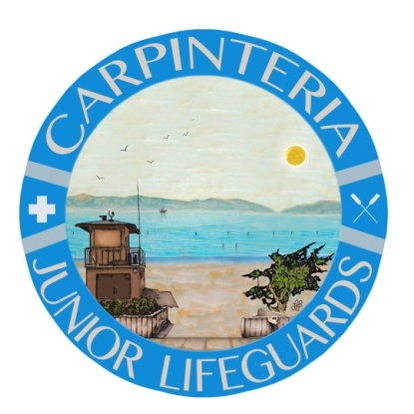
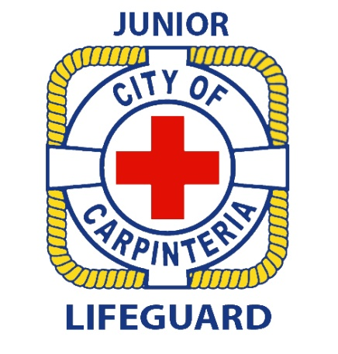
The City of Carpinteria Parks and Recreation believes the Junior Lifeguard Program is a tremendous community asset and benefit to you and your child. However, as our program continues to grow and budget restrictions continue to occur, support is very much welcomed for equipment and supplies. There are also many deserving children in our community who need tuition assistance through scholarships. Consider making a monetary donation to the Carpinteria Junior Lifeguard fund at the Santa Barbara Foundation. If you or your business are interested in making a donation to Carpinteria Junior Lifeguards or have any questions regarding the Santa Barbara Foundation Fund, please contact Matt Roberts at 755-4449. All donations are tax deductible.

We are all looking forward to another successful fun-filled Junior Lifeguard season at the beautiful Carpinteria City Beach – See you there!

